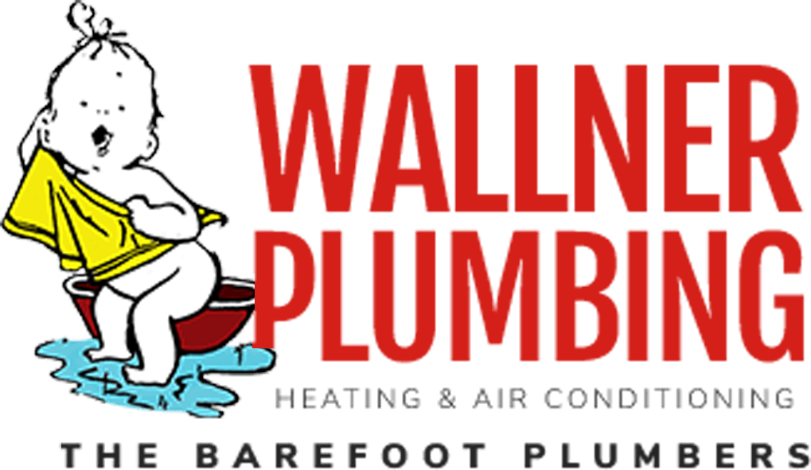

Wallner Plumbing, Heating & Air wishes to ensure our customers that we have continuity plans in place to deliver uninterrupted service and support to customers as we navigate the uncertainty of COVID-19.

As we continue to monitor the COVID-19 situation and the most recent “Shelter in Place Order” by Governor Newsome, We wanted you to know that we are continuing to provide our services in a safe and professional manner.

To protect our customers and our employees, we may ask some additional questions when you call us so we will best understand how to equip our technicians to protect your health and safety as well as theirs.

We have required all of our employees to notify us if they are sick or show any signs of COVID-19, to seek medical attention and not to come to work until cleared to do so.

In return we want to be careful not to expose our essential workforce to any type of pathogens, and so we ask that you inform us if anyone in your home is sick or medically compromised. This way we can determine the best course of action and/or what type of protective gear to be appropriate.

Unfortunately, we are not properly equipped to enter a home where a patient is medically quarantined at this time, nor a home where a customer is self quarantined due to being notified that they may have been exposed to COVID-19.

We will continue to provide our services between 8 am and 5 pm, Monday through Friday with possible restricted or limited emergency services after hours and on weekends. We will continue to provide 24/7 service to our commercial clients that are essential business during the “Shelter in Place” order.

Our pledge to you - Our Technicians will:

- Wear a new set of protective gloves for every job.
- Shoe covers will be worn on every job.

- Protective masks will be worn upon request or where applicable.

- Disposable suits will be worn upon request or when applicable or as required by company policy. (At this time that will apply for all drain line stoppages and some types of work within a bathroom area).
- Our work truck Cab and hand tools will be clean and sanitized frequently each day, as required.
- To practice Social Distancing and minimal intrusion into your home or place of business, we have asked our technicians not shake hands or have any direct contact with anyone while at your home, and to keep the recommended distance at all times, when possible. We also ask you to return the favor.

We thank you for your continued patronage and understanding during these uncertain times.

Please check our website at www.wallnerplumbing.com for additional information and updates.

Take care and be aware!

The Wallner Family and our entire Team of Professionals.

